Department of Electrical Engineering

Faculty Member: Ma’am Neelma Naz Date: November 13, 2025
Semester: 7th Group: 02

CS471 Machine Learning
Lab 9: K-Means Clustering

 |  | PLO4 - CLO4 | PLO4 -CLO4 | PLO5 -CLO5 | PLO8 -CLO6 | PLO9 -CLO7
Name | Reg. No | Viva /Quiz / Lab Performance | Analysis of data in Lab Report | Modern Tool Usage | Ethics | Individual and Team Work
 |  | 5 Marks | 5 Marks | 5 Marks | 5 Marks | 5 Marks
Hanzla Sajjad | 403214
Irfa Farooq | 412564

Introduction
This laboratory exercise is focused on K-means clustering which is a widely used unsupervised learning technique. Clustering is used on unlabeled data to look for interesting groups and patterns.

Objectives
The following are the main objectives of this lab:
- Implement data structures such as lists and dictionaries in python
- Create, alter and loop through lists
- Use slicing to access range of items in a list
- Utilize various list methods such as append, insert, extend, remove, pop etc
- Create and implement a dictionary
- Create Numpy arrays and perform matrix operations and broadcasting
- Use Scipy for minimization, scarce matrices and interpolation

Lab Conduct
- Respect faculty and peers through speech and actions
- The lab faculty will be available to assist the students. In case some aspect of the lab experiment is not understood, the students are advised to seek help from the faculty.
- In the tasks, there are commented lines such as #YOUR CODE STARTS HERE# where you have to provide the code. You must put the code between the #START and #END parts of these commented lines. Do NOT remove the commented lines.
- Use the tab key to provide the indentation in python.
- When you provide the code in the report, keep the font size at 12
- Upon completing the lab, you must delete the manual from the lab computer

Theory
K-means clustering is an unsupervised learning technique that is used to find groups, clusters or patterns in unlabeled. As the dataset is not labelled, only the arrangement of the inputs on the feature space are available. In K-means clustering, K number of clusters are set and then the examples are compared to the cluster centroids. The distance of each feature is used as a metric to define which cluster it belongs to. The cluster centroids are iteratively shifted and the examples belonging to them also change. After enough iterations, useful groups in the feature space are obtained. To determine the best number for clusters, a cost function can be calculated for each K number.
A brief summary of the keywords and functions in python is provided below:

print() output text on console
input() get input from user on console
range() create a sequence of numbers
len() gives the number of characters in a string
if contains code that executes depending on a logical condition
else connects with if and elif, executes when conditions are not met
elif equivalent to else if
while loops code as long as a condition is true
for loops code through a sequence of items in an iterable object
break exit loop immediately
continue jump to the next iteration of the loop
def used to define a function
append(I) append item I to the end of the list
insert(i, I) insert item I at i position of the list
extend(L) extend/concatenate a second list L
remove(I) remove a specified item I from a list
pop(i) remove item at specific index i in the list
count(I) return total number of a specific item I from a list
index(I) return index of first occurrence of a specific item I
reverse reverse the items of the list

For this lab, you will be provided with some dataset files in .csv format which you will need for the tasks. Additionally, for the final task, you will need to arrange your own dataset by downloading it from the internet. You will need to make use of numpy, pandas and matplotlib libraries for the given tasks.

Lab Task 1 – 2-Means Clustering ____________________________________________
In this task, use the provided dataset. Write the code which performs clustering of the dataset into 2 clusters. The pseudocode for the clustering algorithm is provided as follows:
specify K number of centroids
randomly initialize K number of centroids u
for j = 1:epochs
for i = 1:m
c(i) = index of closest cluster to training example
for k = 1:K
u(k) = mean of all training examples indexed to k
plot of x1 and x2 clusters

To determine the index c(i), you will need to write a function that calculates the Euclidean distance between the points in the feature space. This function will be used to find the closest centroid from each training example. After determining the indexes, the cluster centroids themselves are updated by taking the average of the x values. For k-th cluster, the training examples with index k will be averaged. This completes one iteration of clustering after which a scatter plot is made. The iterations are repeated until interesting groups are obtained in the plots.
Due to the initial randomization of cluster centroids, you may have to repeat the clustering a few times. Also, ensure the random centroids are from within the domain of the feature space.
Your code must generate scatter plots showing the clusters at each iteration. The input values must be colored and marked according to the cluster to which they belong at each iteration. The cluster centroids must also be shown Provide all of the codes and screenshots of the final output. You must include plots from at least 3 different iterations showing the progress of your clustering algorithm.
Code
# Import libraries
import numpy as np
import pandas as pd
import matplotlib.pyplot as plt

# Importing required dataset
df = pd.read_csv('basic1.csv')
print(df.head(5))
df = df.values # Changing to numpy arrays

# Specifying initial parameters for number of clusteroids
K_ = 2
epochs = 100
m = df.shape[0]
centroids = df[np.random.choice(m, K_, replace = False)] # Random Initialization
exit = 0 # Default

# Determining closest cluster to training example
def closest_cluster(x, clusteroids, epoch, K, exit):
c = np.zeros(m, dtype = int) # Index array of length m

for j in range(epoch + 1):
old_centroids = clusteroids.copy() # Keep record of old centroids

if(exit == 1):
break

for i in range(m):
c[i] = np.argmin(np.linalg.norm(x[i] - clusteroids, axis = 1))

for k in range(K):
clusteroids[k] = np.mean(x[c == k], axis = 0)

# Comparing difference between the old and new centroid values
shift = np.linalg.norm(clusteroids - old_centroids)

# Cecking if centroid position has updated or not
if shift < 1e-4:
print(f"Converged at iteration {j+1}")
exit = 1
break

# Plot of clusters
plt.scatter(x[:, 0], x[:, 1], c = c)
plt.scatter(clusteroids[:, 0], clusteroids[:, 1], c = 'red')
plt.title(f"Epoch {j+1}")
plt.show()

return clusteroids, c

# Calling function
final_centroids, final_clusters = closest_cluster(df, centroids, epochs, K_, exit)
print(final_centroids)
print(final_clusters)

Output Console
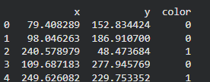

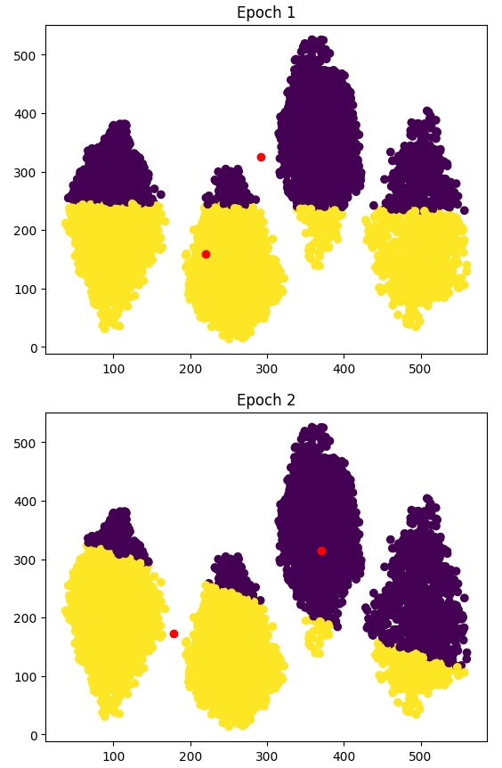 | 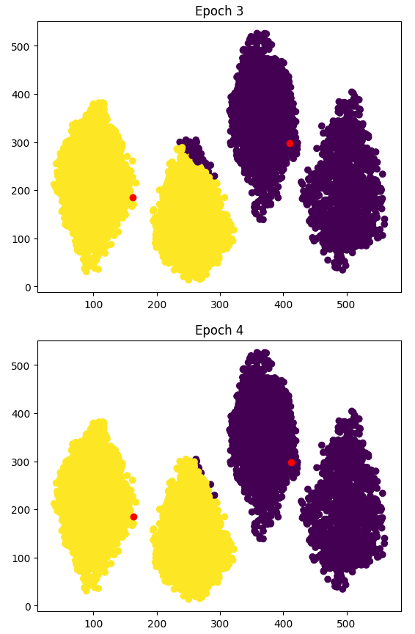
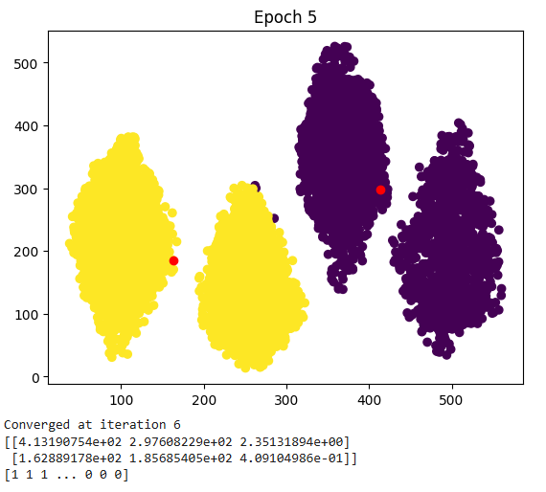

Lab Task 2 – K-Means Clustering ____________________________________________
Repeat task 1, however, set value of K = 3, 4 and 5. For all three K values, generate at least three plots.
Code
# Task 2
K_ = [3, 4, 5]

for i in K_:
centroids = df[np.random.choice(m, i, replace = False)]
final_centroids, final_clusters = closest_cluster(df, centroids, epochs, i, exit)

Output Console
For k = 3
 | 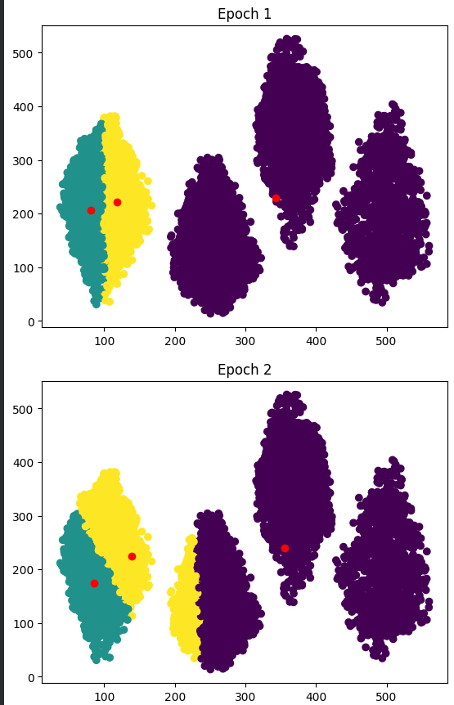 | 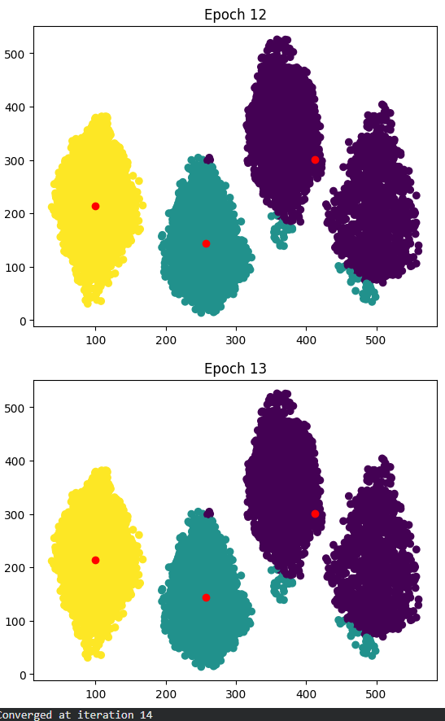
 | For k = 4
 | 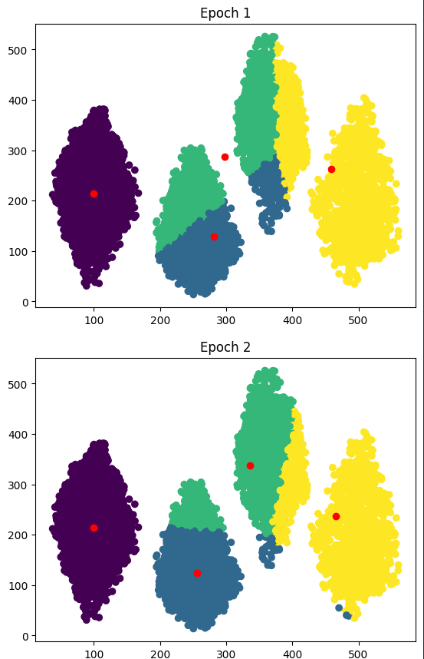 | 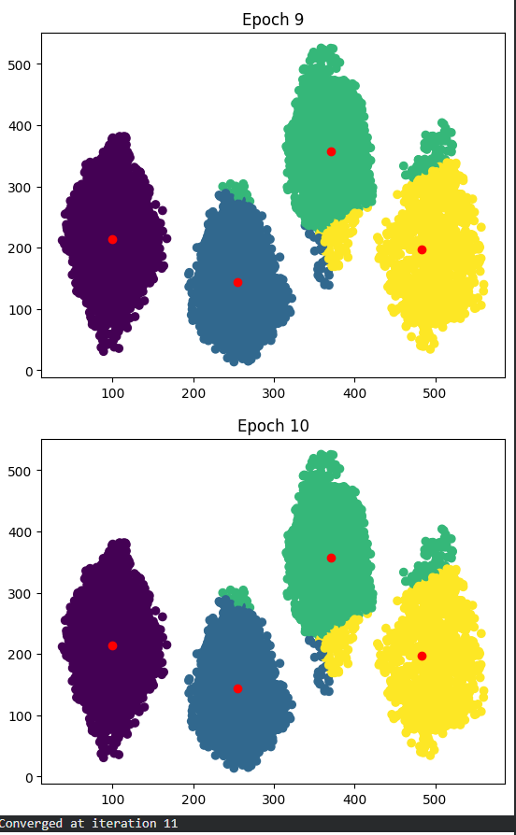

For k = 5
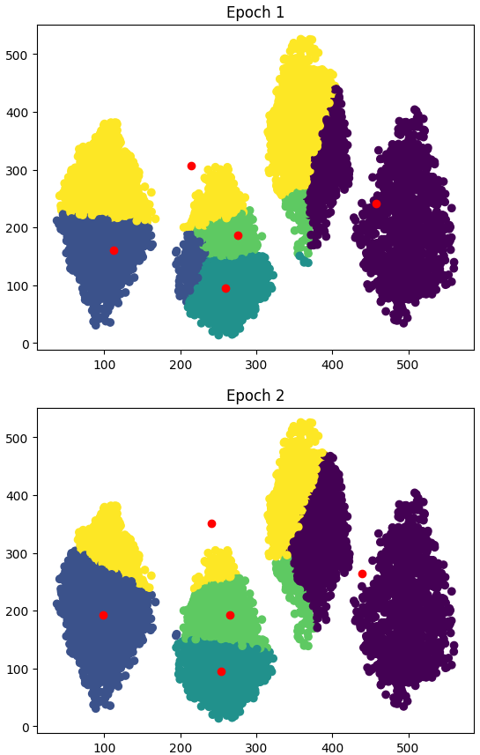 | 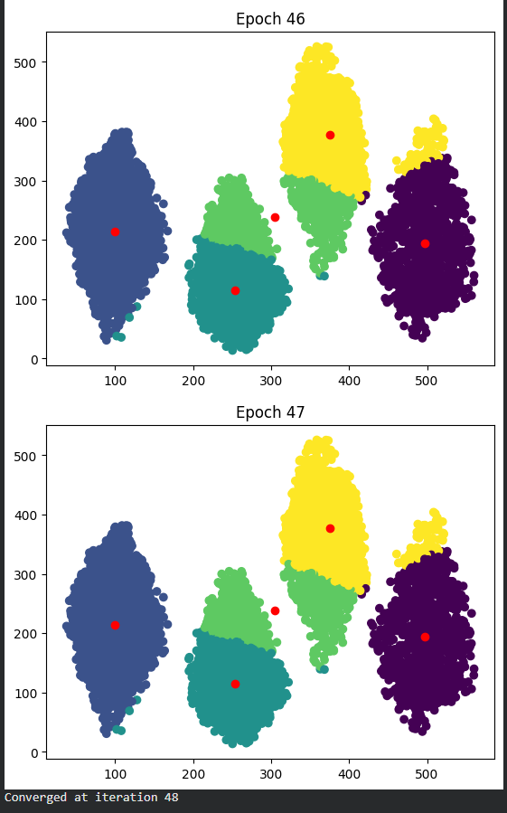

Lab Task 3 – Cost Function _________________________________________________________
Load the given dataset into the python program for this task. In this task, you will modify your code so that it performs clustering from
K = 2, 3, 4… 10.
For each K value, perform about 20 iterations (epochs) of centroid update before moving to the next value of K. Additionally, at the last iteration of each K-value, determine the cost for that K-value:
$${Cost}_{K}=\frac{1}{m}\sum_{i=1}^{m}{{||(x^{\left(i\right)}-µ_{K}^{\left(i\right)})||}^{2}}$$
for K = 1:10
randomly initialize K number of centroids u
for j = 1:epochs
compute cluster centroids u(k)
plot of x1 and x2 clusters
compute cost for current K value
plot of cost and K
Store the costs for each K value in a list. After the last iteration of the last cluster, make a plot of K vs. cost.
Code
# Task 3: Elbow Method
epochs = 20
Ks = range(2, 11)
costs = []

for K in Ks:
centroids = df[np.random.choice(m, K, replace=False)]
exit = 0

final_centroids, final_clusters = closest_cluster(
df, centroids, epochs, K, exit
)

cost = 0
for i in range(m):
assigned_centroid = final_centroids[final_clusters[i]]
cost += np.linalg.norm(df[i] - assigned_centroid)**2

cost = cost / m
costs.append(cost)

plt.figure(figsize=(7,5))
plt.plot(list(Ks), costs, marker='o')
plt.xlabel('K')
plt.ylabel('Cost (Average Squared Distance)')
plt.title('Elbow Method: K vs Cost')
plt.grid(True)
plt.show()

Output Console
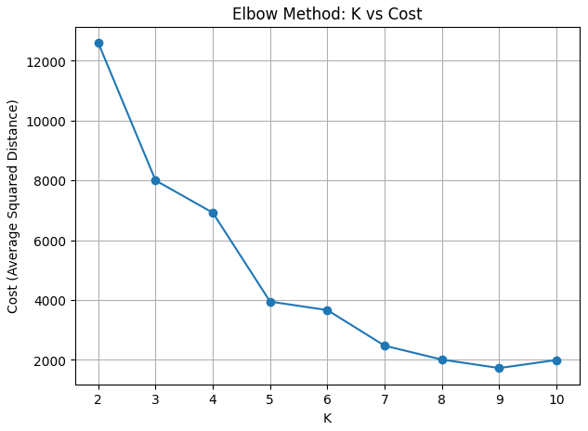

Lab Task 4 – Your Own Dataset ___________________________________________________
Download your own CSV dataset from the internet (e.g. Kaggle). Your dataset must have at least 500 rows and at least 4 feature columns. Perform clustering of your dataset and showcase the plots (the cost function is optional in this task).

Dataset Details
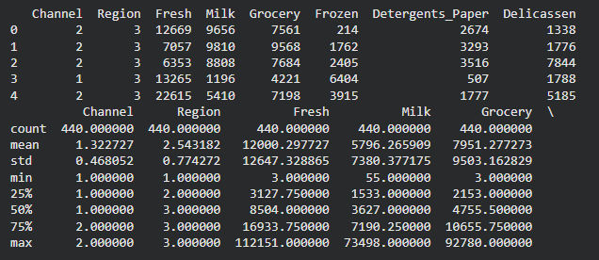
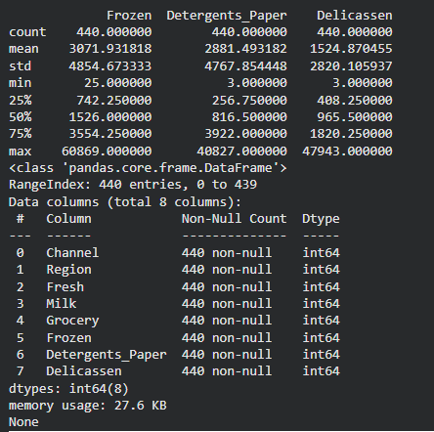
Output Console
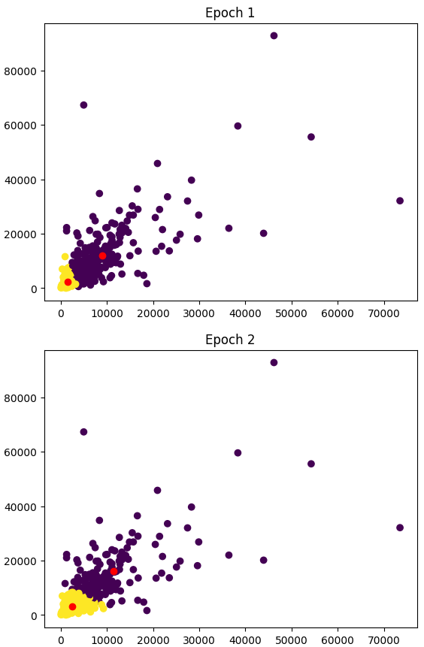 | 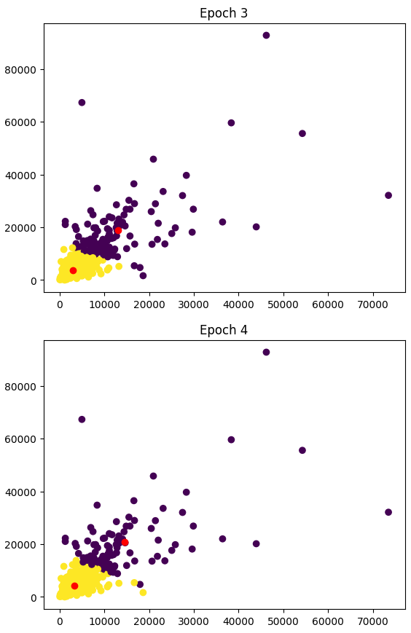
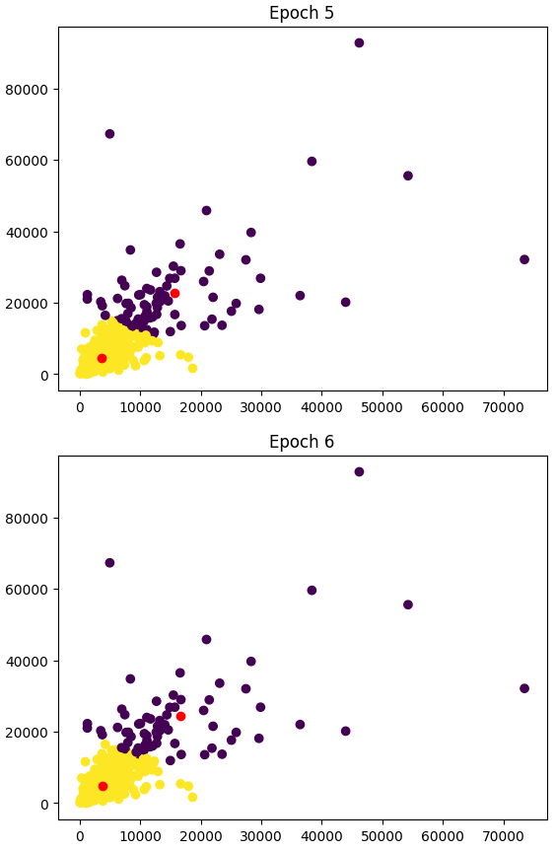 | 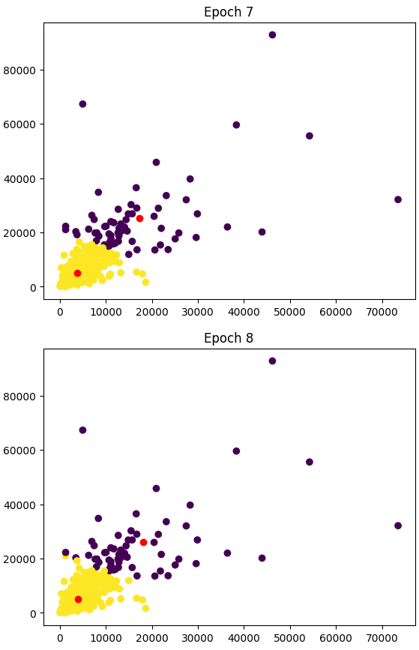
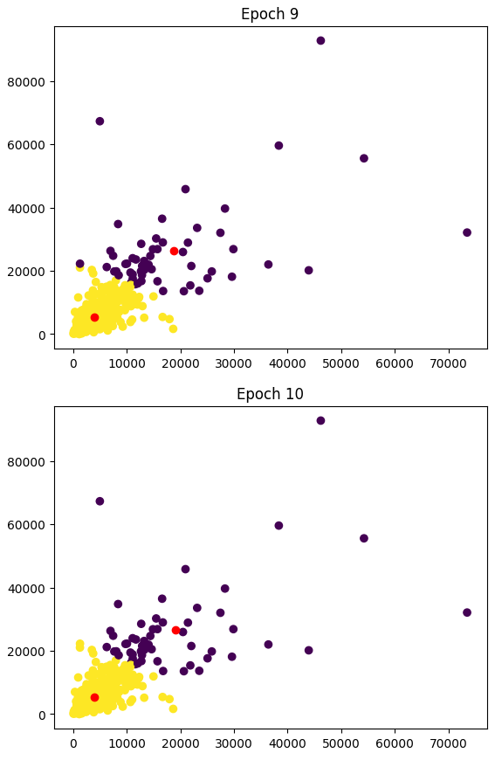 | 